Project Introduction Autonomous Bicycle

This document is an introduction of the autonomous bicycle project, aiming to show the project details for better problem understanding and further discussion.

The project will be discussed in hardware specification and control loop.

Contents

Current issues 2

Hardware Specification 3

Bike overview 3

Control loop 5

Block diagram 5

Bike Model 5

State Space Form: 6

LQR Controller 7

Steering Motor 8

Disturbance sensitivity 11

Disturbances on the steering motor 11

Disturbances on the full control loop 12

Sensors 14

IMU 14

Hall Speed Sensor 14

Encoder 14

# Current issues

* While the bike balances in simulation in the presence of perturbations and noise, on the real bike the steering angle presents growing oscillations and does not balance.
* Is our model a representation of the bike’s dynamics that is sufficiently close to the real bike so that controllers developed in simulation will balance the real bike? Do we need more states/parameters or a more complex model? It is missing important dynamics from the real bike, i.e. vibrations in the mechanical structure?
* In simulation, adding a low-pass filter to the measured roll rate leads the balancing control loop with LQR controller to become unstable. The filters are Butterworth filters with cutoff frequency of 1Hz as experimental data show oscillations of around 2Hz in roll rate and the bandwidth of the balancing loop is 0.17Hz. Is this a behavior to be expected on the real bike or it is specific to our simulation?

# Hardware Specification

This section presents the main components of the bike and their positions.

## 

## Bike overview

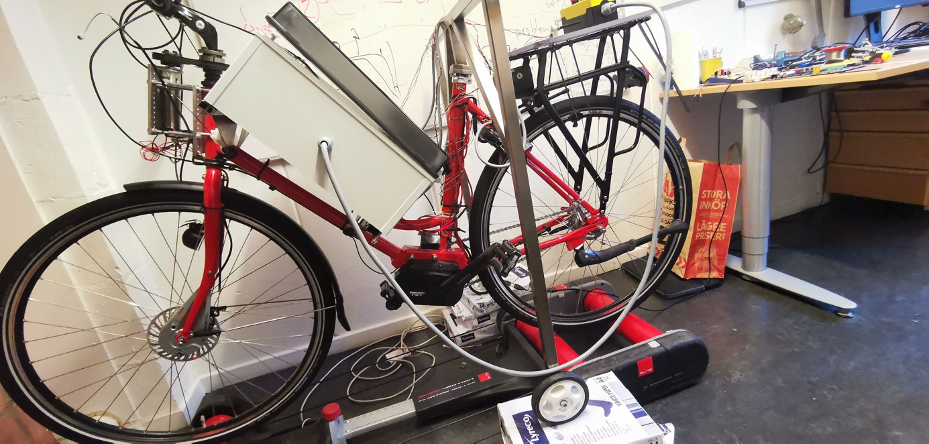

* + Steering Motor + Encoder (Motor: DCX32LGB KL 24V & GPX32HP 111:1, Encoder: HEDS 5540)
* Electronics Box (details shown later)
* IMU (PmodNAV : LSM9DS1 accelerometer)
* Drive Motor (Shimano E6000 series)
* Support Bar
* Rear wheel Hall Speed Sensor (Honeywell 103SR13A-1)
* Emergency Stop

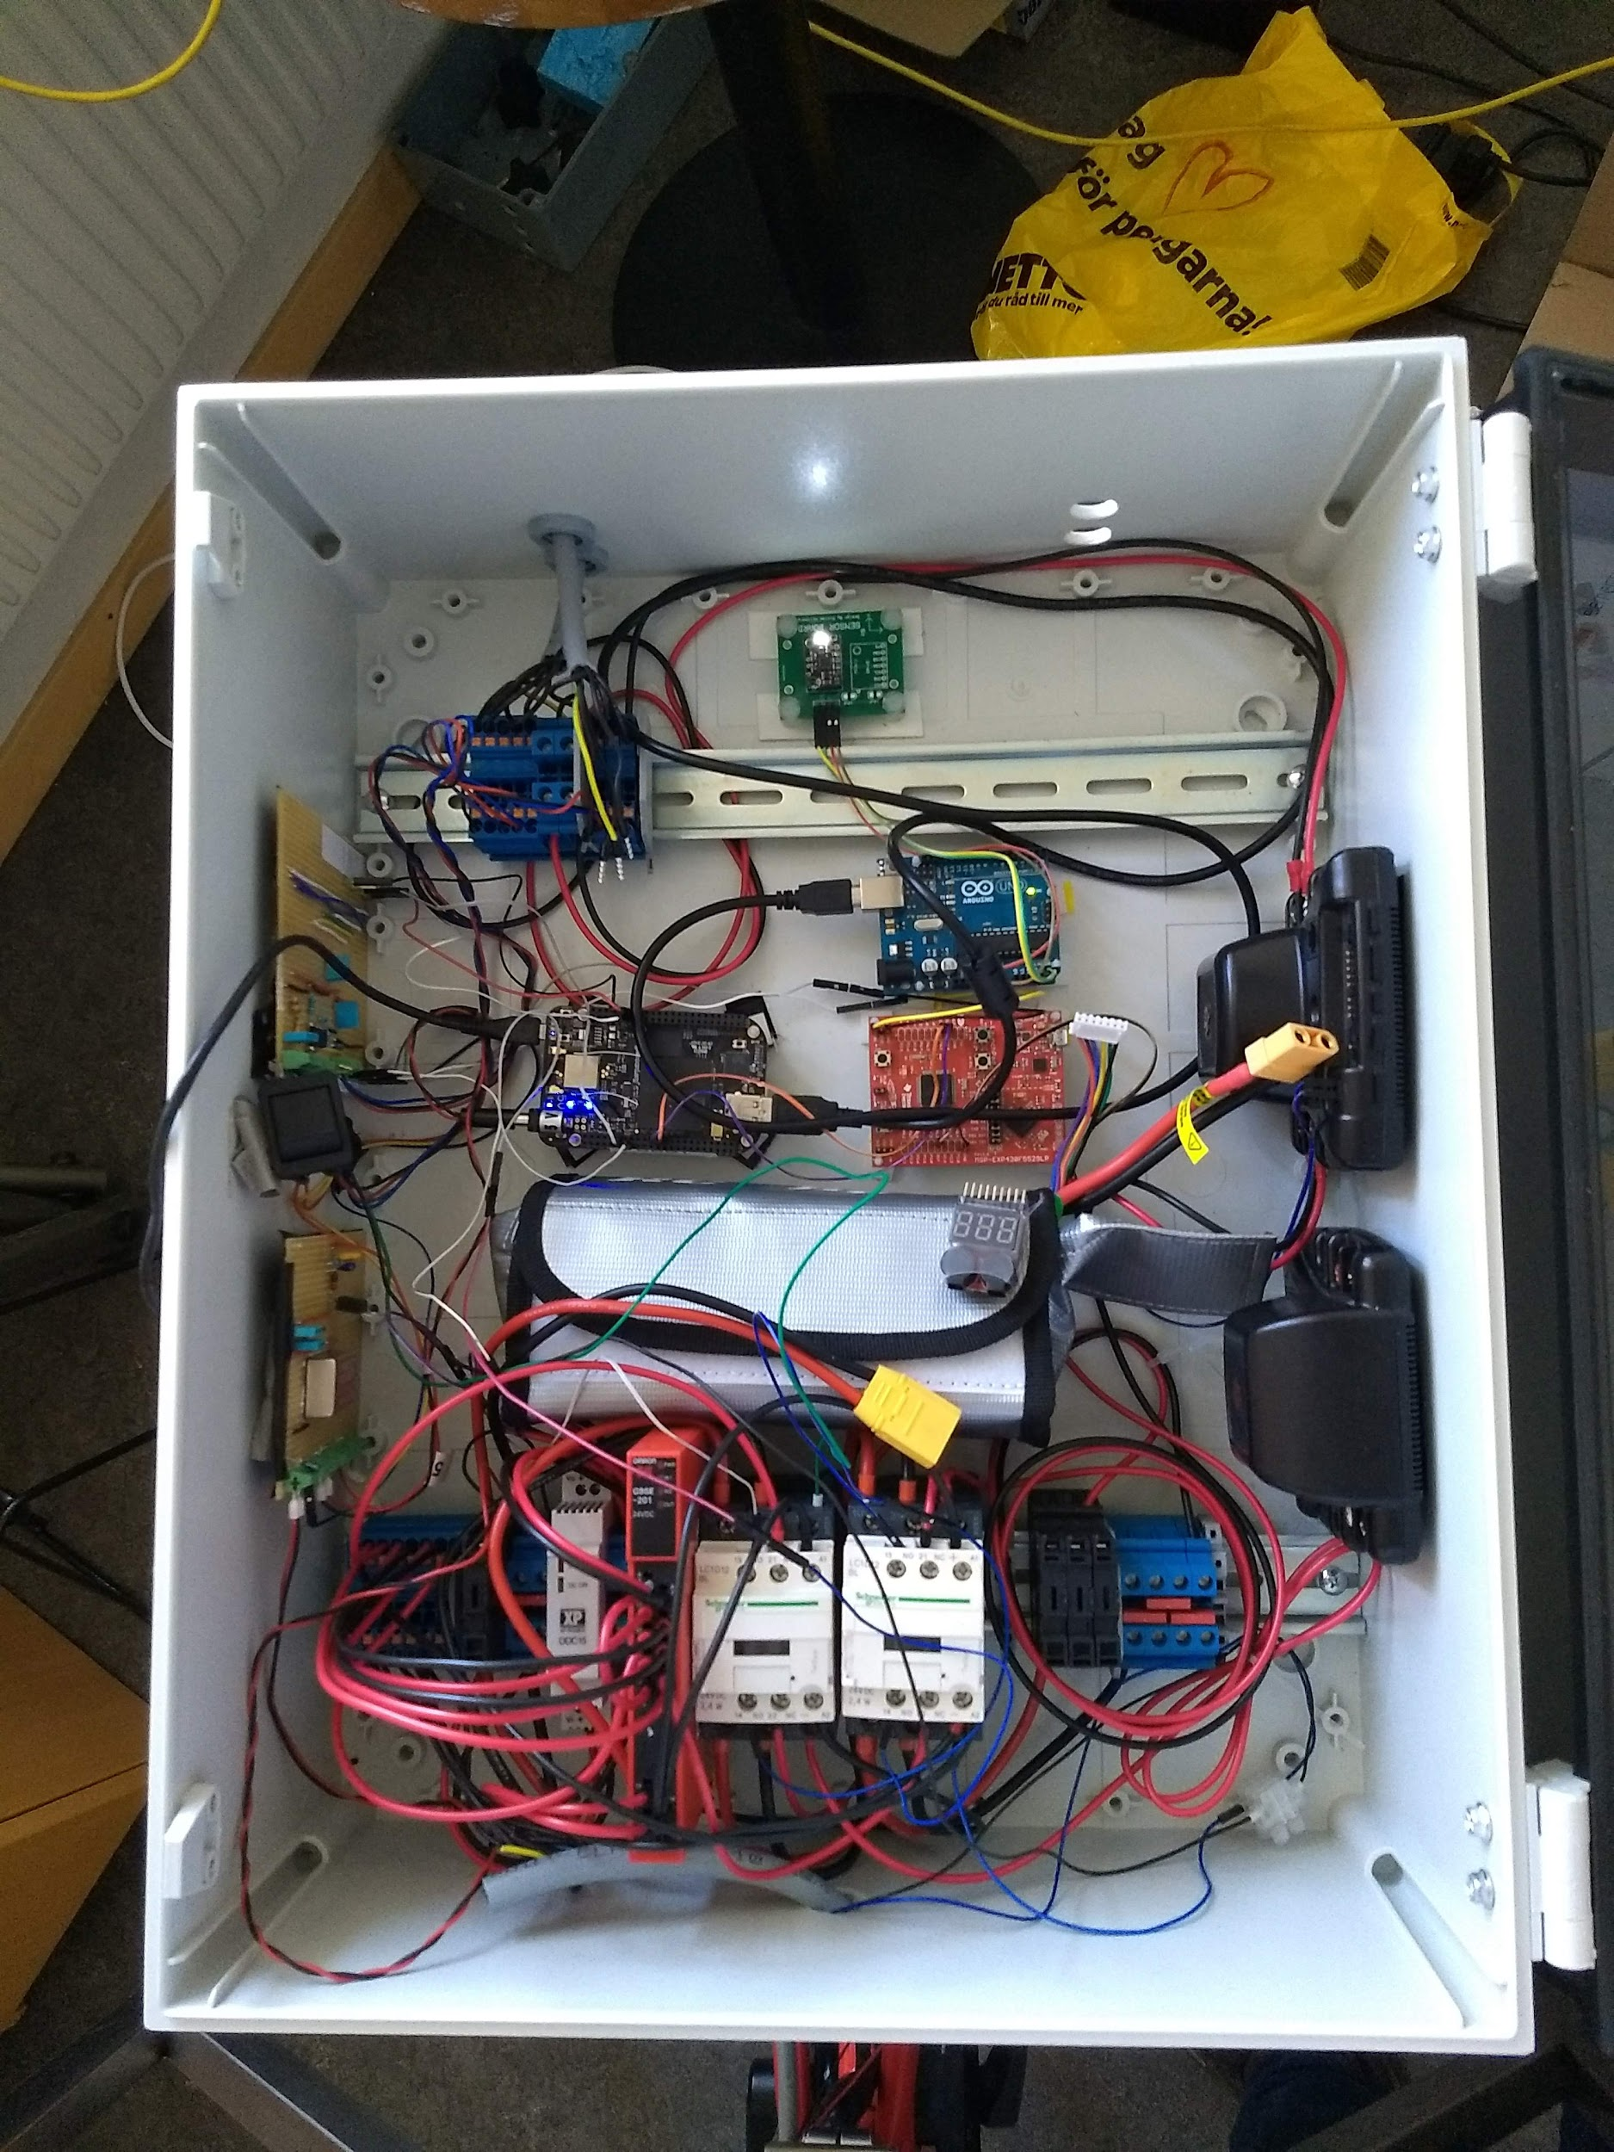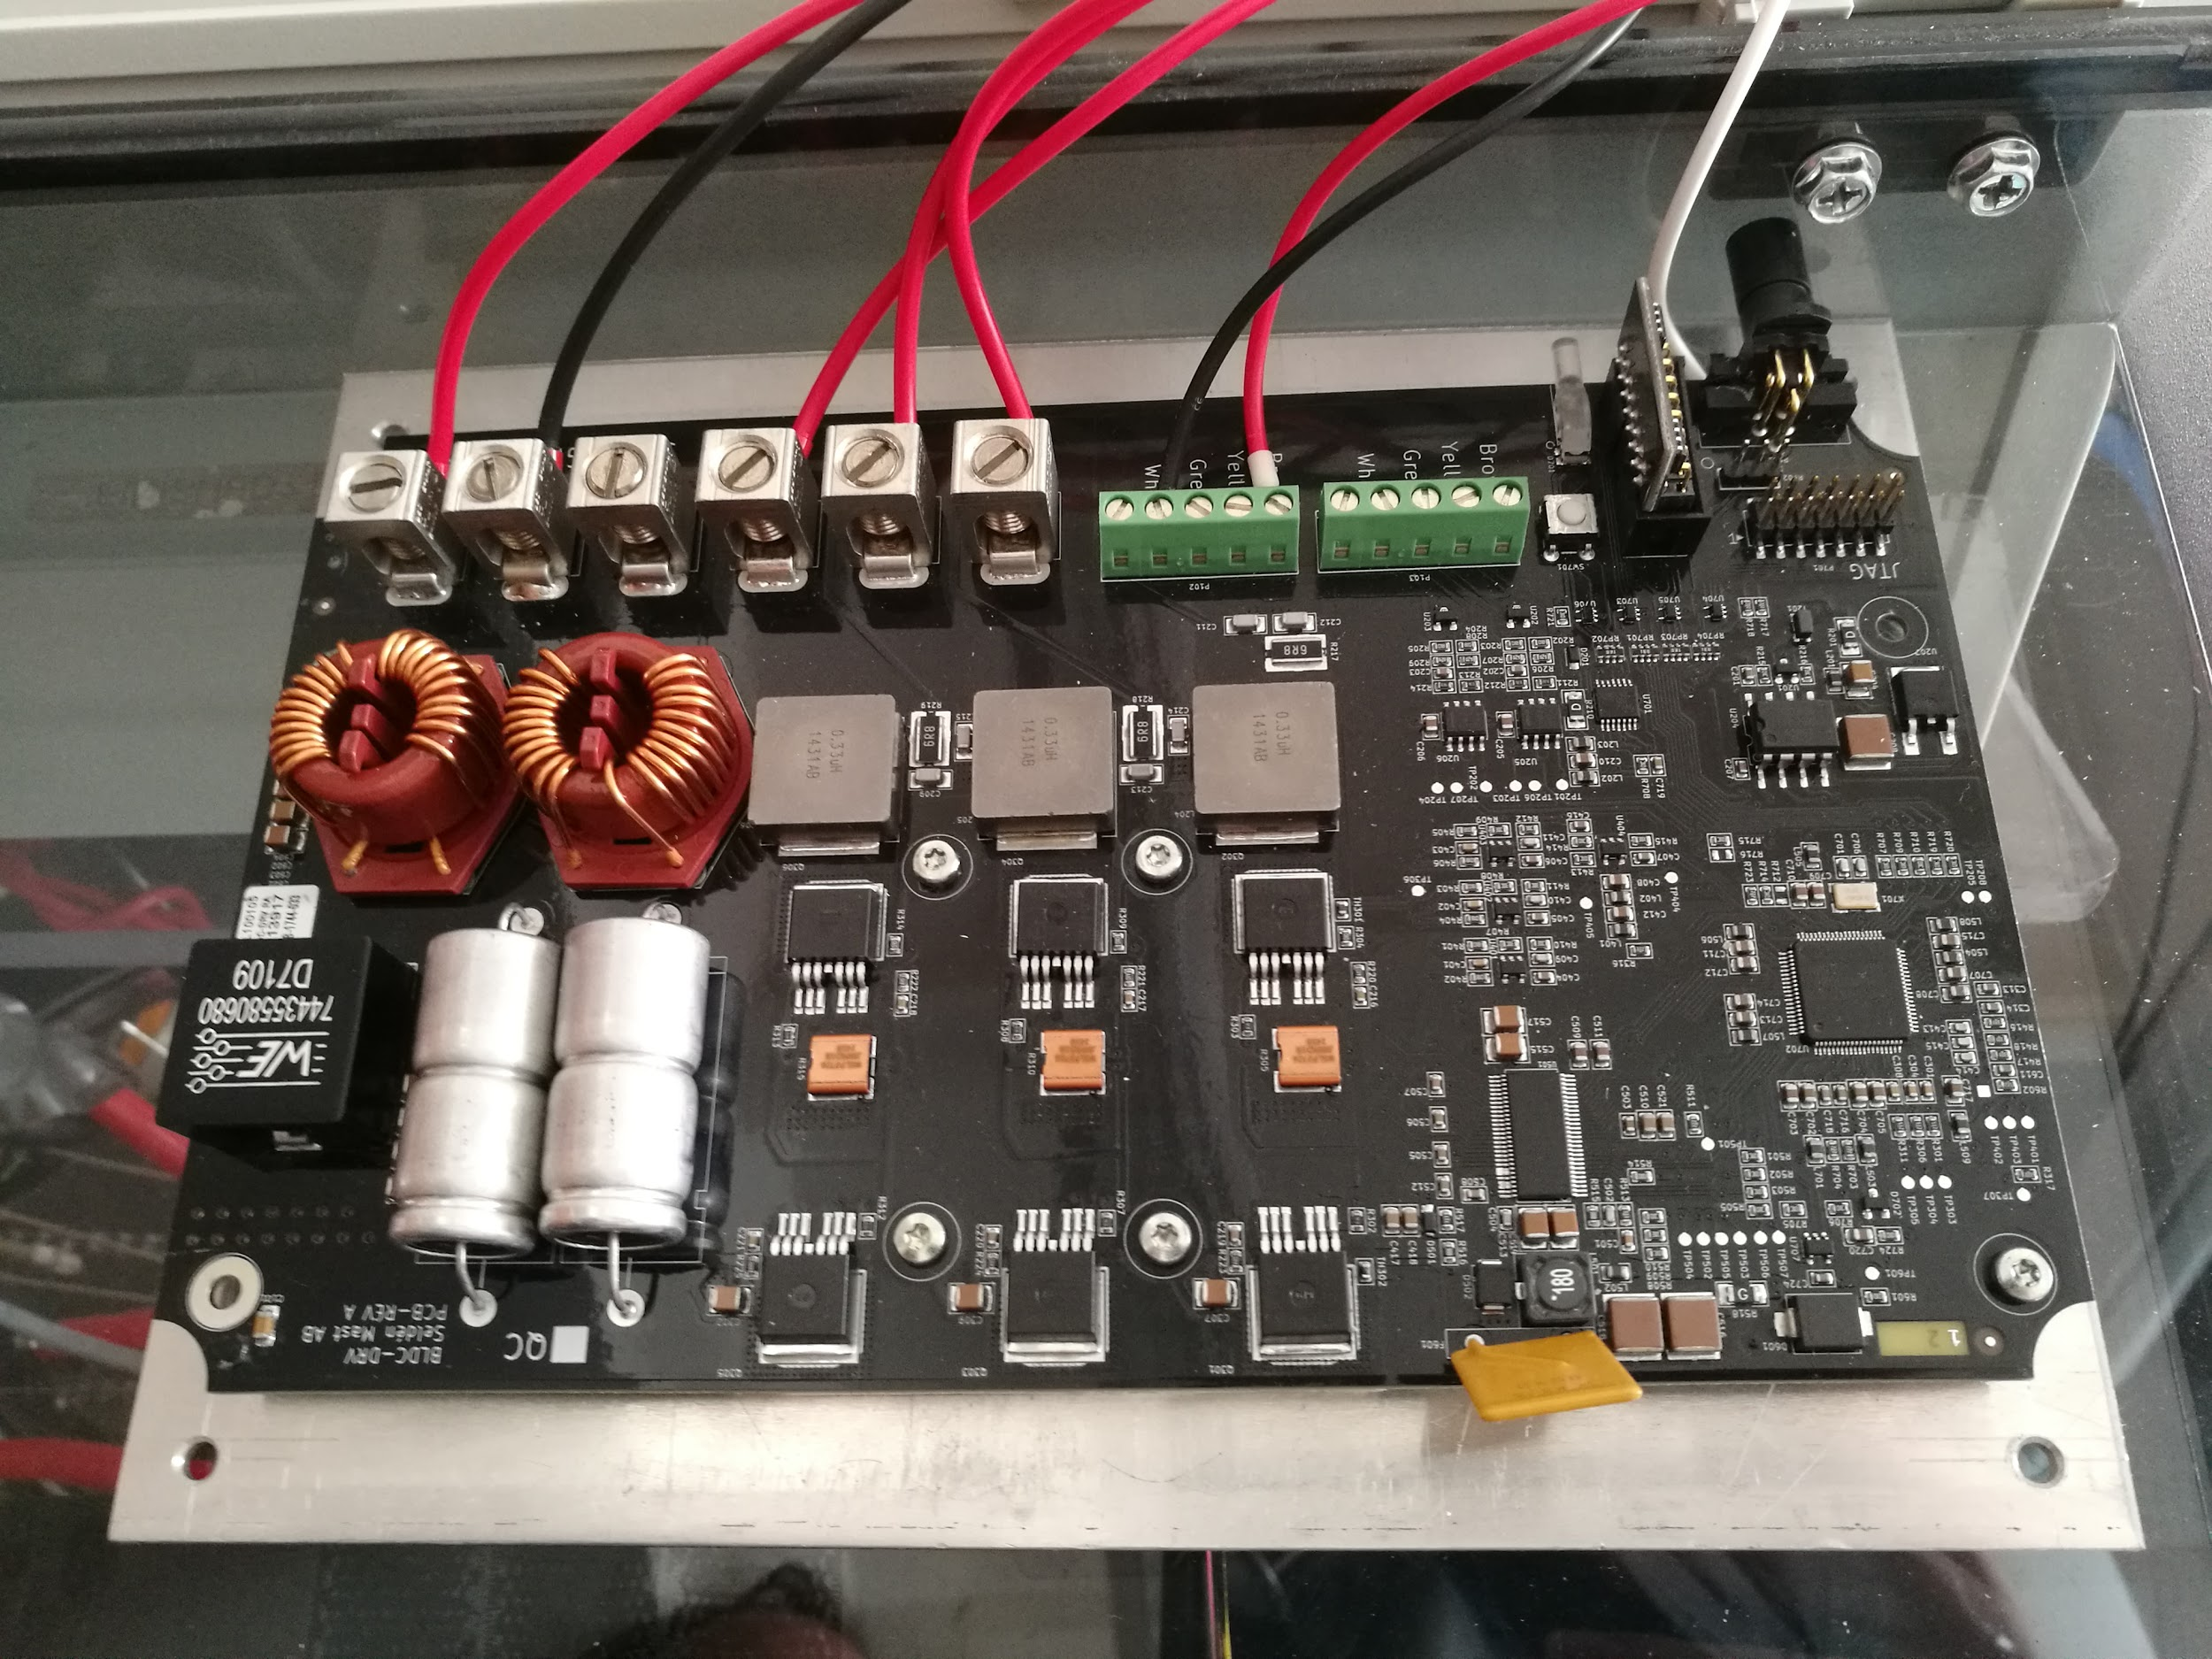

The components highlighted by boxes are the ones that are currently on use in the bike. The rest are not used anymore.

* Onboard computer (BeagleBone Black)
* 6S LiPo Battery
* Safety Relay and Contactors
* Steering Motor Controller (Maxon Escon 50/5)
* Drive Motor Controller

# Control loop

## Block diagram of the control loop

This section presents the control loop that is used to balance the bike.



Figure 1 – Block diagram of the bike and self-balancing control loop

$V$: true forward velocity

$\hat{V}$: measured forward velocity

$V_{ref}$: reference forward velocity

$ϕ,δ,\dot{ϕ}$: true roll, steering angle and roll rate

$\hat{ϕ},\hat{δ},\hat{\dot{ϕ}}$: measured roll, steering angle and roll rate

$ϕ_{ref},δ_{ref},{\dot{ϕ}}_{ref}$: reference roll, steering angle and roll rate

$δ_{ref}^{LQR}$: reference steering angle generated by the LQR self-balancing controller

$δ_{dist},{\hat{ϕ}}_{dist},{\hat{δ}}_{dist},{\hat{\dot{ϕ}}}_{dist}$: disturbances on true steering angle, measured roll, measured steering angle and measured roll rate

The control loop runs at a sampling frequency of 100Hz.

The measurements are obtained as follows:

* measured roll rate $\hat{\dot{ϕ}}$ obtained directly from the IMU (resolution of 8.75 mdps)
* measured steering angle $\hat{δ}$ obtained directly from the steering encoder (resolution of 0.0065deg)
* measure roll $\hat{ϕ}$ obtained with a complementary filter using accelerations and roll rate measured by the IMU

## Bike Model

This section presents the linear model of the bike that will be used for control design. The model can be found in ‘*Bicycle Dynamics and Control*’, Åstrom et al. (<https://ieeexplore.ieee.org/abstract/document/1499389>).

### Transfer Function Form:

Input : steering angle $δ$

Output : leaning angle $Φ$

$$\begin{aligned}Φ\left(s\right)=-\frac{V\left(a s + V\right)}{b\left(g-hs^{2}\right)}δ\left(s\right)\#\left( SEQ Eq \backslash * MERGEFORMAT 1\right)\end{aligned}$$

where :

$V=4 m/s$ is the forward velocity.

$a=0.4964 m$ is the horizontal distance between the rear wheel center to the center of the mass.

$b=1.095 m$ is the bike body horizontal length

$h=0.5195 m$ is the height of the center of the mass

$g=9.81 m/s^{2}$ is the gravitational acceleration

Poles are at +/- 4.3455 and the bandwidth is 0.49Hz.

### State Space Form:

As we focus on control design, we will use the controllable canonical realization:

$$\begin{aligned}\dot{x}=Ax+Bδ\#\left( SEQ Eq \backslash * MERGEFORMAT 2\right)\end{aligned}$$

$$\begin{aligned}y=φ=Cx\#\left( SEQ Eq \backslash * MERGEFORMAT 3\right)\end{aligned}$$

$$\begin{aligned}A=\left[\begin{matrix}0 & \frac{g}{h} \\ 1 & 0\end{matrix}\right]\#\left( SEQ Eq \backslash * MERGEFORMAT 4\right)\end{aligned}$$

$$\begin{aligned}B=\left[\begin{matrix}1 \\ 0\end{matrix}\right]\#\left( SEQ Eq \backslash * MERGEFORMAT 5\right)\end{aligned}$$

$$\begin{aligned}C=\left[\begin{matrix}\frac{aV}{bh} & \frac{V^{2}}{bh}\end{matrix}\right]\#\left( SEQ Eq \backslash * MERGEFORMAT 6\right)\end{aligned}$$

It is possible to switch between the states $x$ and the roll and roll rate $\left[\begin{matrix}ϕ \\ \dot{ϕ}\end{matrix}\right]$ as follows :

$$\begin{aligned}\left[\begin{matrix}ϕ \\ \dot{ϕ}\end{matrix}\right]=\left[\begin{matrix}Cx \\ C\dot{x}\end{matrix}\right]=\left[\begin{matrix}Cx \\ C\left(Ax+Bδ\right)\end{matrix}\right]=\left[\begin{matrix}C \\ CA\end{matrix}\right]x+\left[\begin{matrix}0 \\ CB\end{matrix}\right]δ\#\left( SEQ Eq \backslash * MERGEFORMAT 7\right)\end{aligned}$$

$$\begin{aligned}x={\left[\begin{matrix}C \\ CA\end{matrix}\right]}^{-1}\left(\left[\begin{matrix}ϕ \\ \dot{ϕ}\end{matrix}\right]-\left[\begin{matrix}0 \\ CB\end{matrix}\right]δ\right)\#\left( SEQ Eq \backslash * MERGEFORMAT 8\right)\end{aligned}$$

## LQR Controller

This section presents the design of the LQR controller used to balance the bike. The LQR controller loop is presented in Figure 2. The LQR gain is $K_{LQR}$.



Figure 2 - Block diagram of the LQR controller

The LQR controller is designed using the following cost function:

$$\begin{aligned}J=\sum_{k=0}^{+∞}{\left({\left[\begin{matrix}ϕ(k) \\ \dot{ϕ}(k)\end{matrix}\right]}^{T}Q\left[\begin{matrix}ϕ(k) \\ \dot{ϕ}(k)\end{matrix}\right]+{δ(k)}^{T}Rδ(k)\right)}\#\left( SEQ Eq \backslash * MERGEFORMAT 9\right)\end{aligned}$$

The LQR controller is tuned by ignoring the dynamics of the steering motor. The weighting matrices $Q$ and $R$ are defined as:

$$\begin{aligned}Q=\left[\begin{matrix}10 & -9 \\ -9 & 10\end{matrix}\right]\#\left( SEQ Eq \backslash * MERGEFORMAT 10\right)\end{aligned} \\ \begin{aligned}R=1\#\left( SEQ Eq \backslash * MERGEFORMAT 11\right)\end{aligned}$$

The cost function is then transformed to use states $x$ instead of $\left[\begin{matrix}ϕ \\ \dot{ϕ}\end{matrix}\right]$ using Equation $7$, leading to:

$$\begin{aligned}J=\sum_{k=0}^{+∞}{\left({x(k)}^{T}Q_{x}x(k)+{u(k)}^{T}R_{x}u(k)+2{u(k)}^{T}N_{x}x(k)\right)}\#\left( SEQ Eq \backslash * MERGEFORMAT 12\right) \\ Q_{x}={\left[\begin{matrix}C \\ CA\end{matrix}\right]}^{T}Q\left[\begin{matrix}C \\ CA\end{matrix}\right]\#\left( SEQ Eq \backslash * MERGEFORMAT 13\right) \\ R_{x}={\left[\begin{matrix}0 \\ CB\end{matrix}\right]}^{T}Q\left[\begin{matrix}0 \\ CB\end{matrix}\right]+R\#\left( SEQ Eq \backslash * MERGEFORMAT 14\right) \\ N_{x}={\left[\begin{matrix}0 \\ CB\end{matrix}\right]}^{T}Q\left[\begin{matrix}C \\ CA\end{matrix}\right]\#\left( SEQ Eq \backslash * MERGEFORMAT 15\right)\end{aligned}$$

Continuous time poles are at -1.0252 and -8.0451 and the bandwidth is 0.17Hz.

## Steering Motor

This section presents the model of the steering motor and the design of the steering angle controller.

As the LQR controller gives a reference steering angle and the steering motor expects a reference steering rate, a controller for the steering motor is needed.

The block diagram of the steering motor is presented in Figure 3.



Figure 3 - Block diagram of the steering motor

In order to test the controller in simulation, an open-loop identification of the steering motor is done. The model of the steering motor is identified from experimental data as a first-order transfer function:

$$\begin{aligned}G_{steering}=\frac{\dot{δ}}{{\dot{δ}}_{ref}^{LQR}}=\frac{253.4}{s+245.9}\#\left( SEQ Eq \backslash * MERGEFORMAT 16\right)\end{aligned}$$

The pole of this transfer function is at -245.9. The integrator adds a pole at 0.

The steering reference is tracked using a PI controller as presented in Figure 4. ${\dot{δ}}_{dist}$ is a disturbance on steering rate.



Figure 4 - Block diagram of the steering motor with steering angle feedback

As the steering control loop is an inner loop to the bike balancing control loop, it is necessary that the former is faster than the latter. We will aim to have a steering control loop with a rise time (from 10% to 90%) 5 times smaller than the bike balancing control loop. The rise time of the balancing loop is 2.19s, therefore we aim for a rise time of less than 0.44s for the steering control loop.

The steering angle’s step response shows oscillations for a P controller with P=60, therefore Table 1 presents cases up to half this value (P=30). Increasing the integral gain I moves the pole closest to the imaginary axis farther from the imaginary axis but increases overshoot as presented in Figure 5 and Figure 6. I=30 has been chosen as a compromise.

Table 1 presents the continuous time poles of the steering control loop (assuming that $\hat{δ}=δ$) and the continuous time poles of the bike balancing control loop for varying gains of PI steering controller. Several gains for the PI controller are compared in order to find ones that make the steering control loop fast enough.

In the case where P=1 and I=0, the steering control is too slow and the balancing loop becomes unstable.

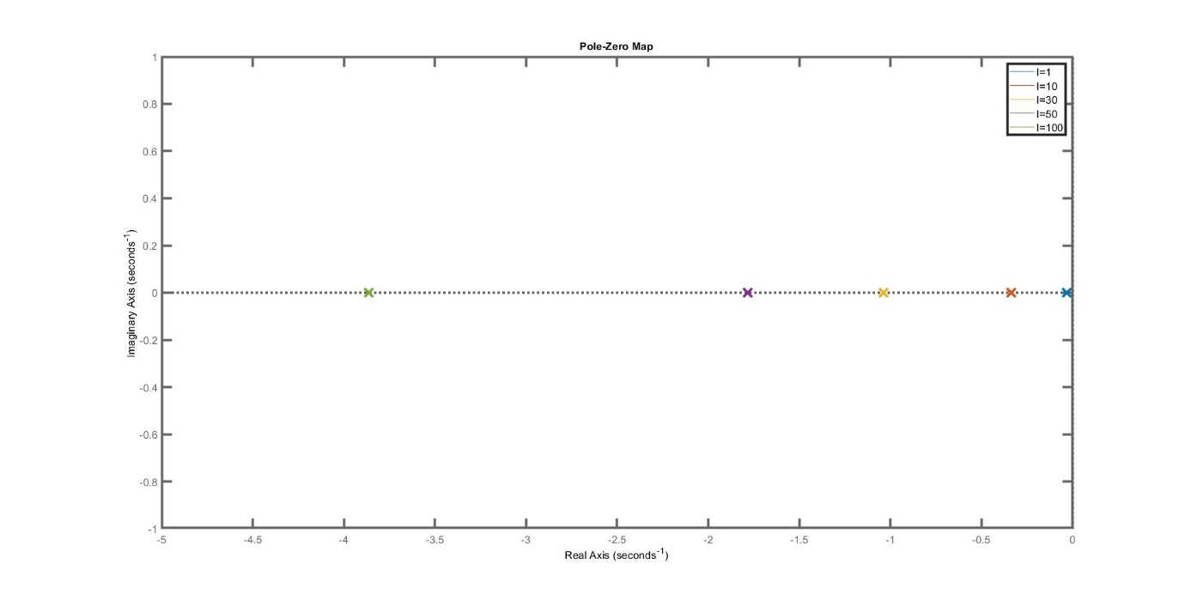

Figure 5 - Effect of the integral gain on the position of the pole closest to the imaginary axis of the steering angle control loop

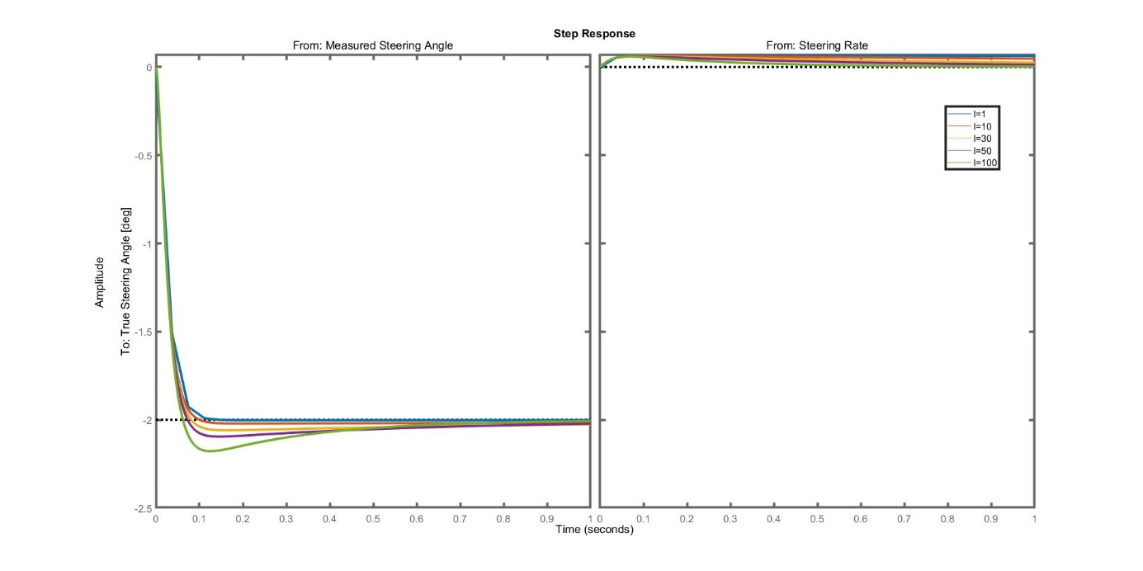

Figure 6 - Effect of the integral gain on the step response of the steering angle control loop

|  |  |  |  |  |  |  |
| --- | --- | --- | --- | --- | --- | --- |
| P | I | Poles of the steering control loop | Stability steering | Rise time | Poles of the bike balancing control loop | Stability bike |
| No steering motor dynamics, only bike balancing control loop | | | | | -1.0252 ; -8.0451 | Stable |
| 1 | 0 | -241.46 ; -1.04 | Stable | 2.11s | -241.58 ; -3.96 ; 1.89 ; 1.11 | Unstable |
| 10 | 0 | -204.17 ; -11.45 | Stable | 0.192s | -206.44 ; -1.34 ;  -4.53 + 6.91i ;  -4.53 - 6.91i | Stable |
| 30 | 0 | -124.17 ; -50.68 | Stable | 0.05s | -133.86 ; -1.10 ;  -11.77 ; -29.29 | Stable |
| 30 | 1 | -124.24 ;  -50.58 ; -0.03 | Stable | 0.05s | -133.90 ; -29.18 ;  -11.81 ; -1.10 ; -0.03 | Stable |
| 30 | 10 | -124.90 ;  -49.77 ; -0.34 | Stable | 0.05s | -134.40 ; -28.14 ;  -12.16 ; -1.14 ; -0.32 | Stable |
| 30 | 30 | -126.34 ;  -47.97 ; -1.04 | Stable | 0.05s | -135.52 ; -25.57 ;  -13.26 ; -1.41 ; -0.78 | Stable |

Table 1 - Poles of the steering control loop and bike balancing control loop for varying PI steering controller from simulations.

## Disturbance sensitivity

### Disturbances on the steering motor

We will study the following disturbances on the steering motor:

* Steering rate ${\dot{δ}}_{dist}$
* Measured steering angle ${\hat{δ}}_{dist}$

The simulations are done using $P=30$ and $I=30$ in the steering angle controller with the steering motor isolated from the rest of the bike such as in Figure 4. We assume that $\hat{δ}=δ$ for the feedback. For each disturbance, we will show a step response in Figure 7 (2deg measured steering angle, 2deg/s steering rate) and Bode plots in Figure 8.

The controller shows rejects the disturbance on steering rate as the steering angle converges to 0 on the left plot of Figure 7. The two left plots of Figure 8 show a resonance around 1Hz with a gain of -30dB, therefore a steering rate disturbance will be attenuated at least 30 times in the steering angle control loop.

The right plot of Figure 7 shows that the controller is sensitive to a measured steering angle disturbance and will not reject it. The true steering angle converges to the opposite of the amplitude of the step (-2deg). This can be interpreted as follows : the controller will steer the measured steering angle to the reference of 0deg but, as the measured steering angle has a +2deg offset with respect to the true steering angle, the true steering angle will then converge to -2deg.

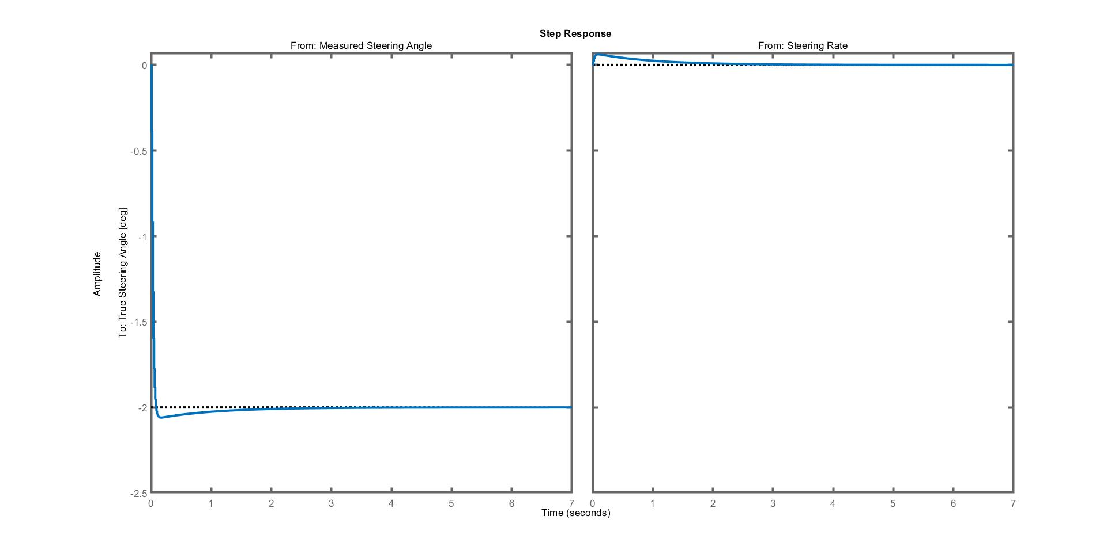

Figure 7 - Step response of step perturbations. From left to right, disturbances on: steering rate (2deg/s step), measured steering angle (2deg)

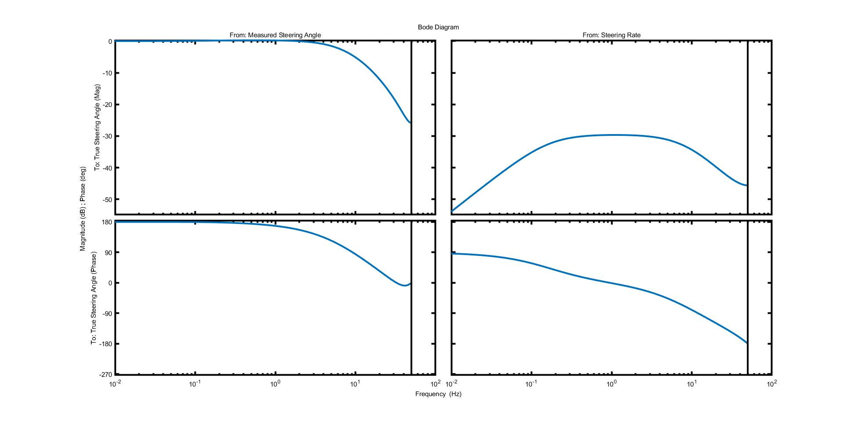

Figure 8 - Bode plots of perturbations. From left to right, disturbances on: steering rate, measured steering angle. From top to bottom: Bode magnitude plots measured for true steering angle, Bode phase plots for true steering angle.

### Disturbances on the full control loop

We will study the following disturbances on the bike :

* measured roll ${\hat{ϕ}}_{dist}$
* measured roll rate ${\hat{\dot{ϕ}}}_{dist}$
* true steering angle $δ_{dist}$
* measured steering angle ${\hat{δ}}_{dist}$

The effects of the disturbances are observed on the following signals:

* true roll $ϕ$
* true roll rate $\dot{ϕ}$
* true steering angle $δ$

The simulations are done using $P=30$ and $I=30$ in the steering angle controller.

For each disturbance, we will show a step response in Figure 9 (2deg roll/steering angle, 2deg/s roll rate/steering rate) and Bode plots in Figure 10.

Figure 9 shows that the bike remains stable for step response of the four tested disturbances as the roll rate converges to 0. Figure 10 shows that the balancing controller is unable reject low frequency disturbances on measured roll, roll rate and steering angle and high frequency disturbances on true steering angle: in these cases the gain from disturbance to true roll and true steering angle is around 0dB.

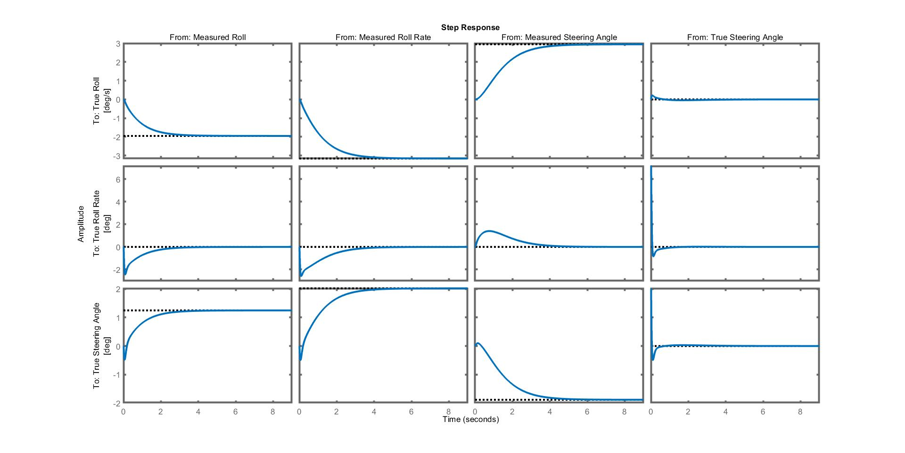

Figure 9 - Step response of step perturbations. From left to right, disturbances on: measured roll (2deg step), measured roll rate (2deg/s), measured steering angle (2deg), true steering angle (2deg/s). From top to bottom: true roll, true steering angle, true roll rate.

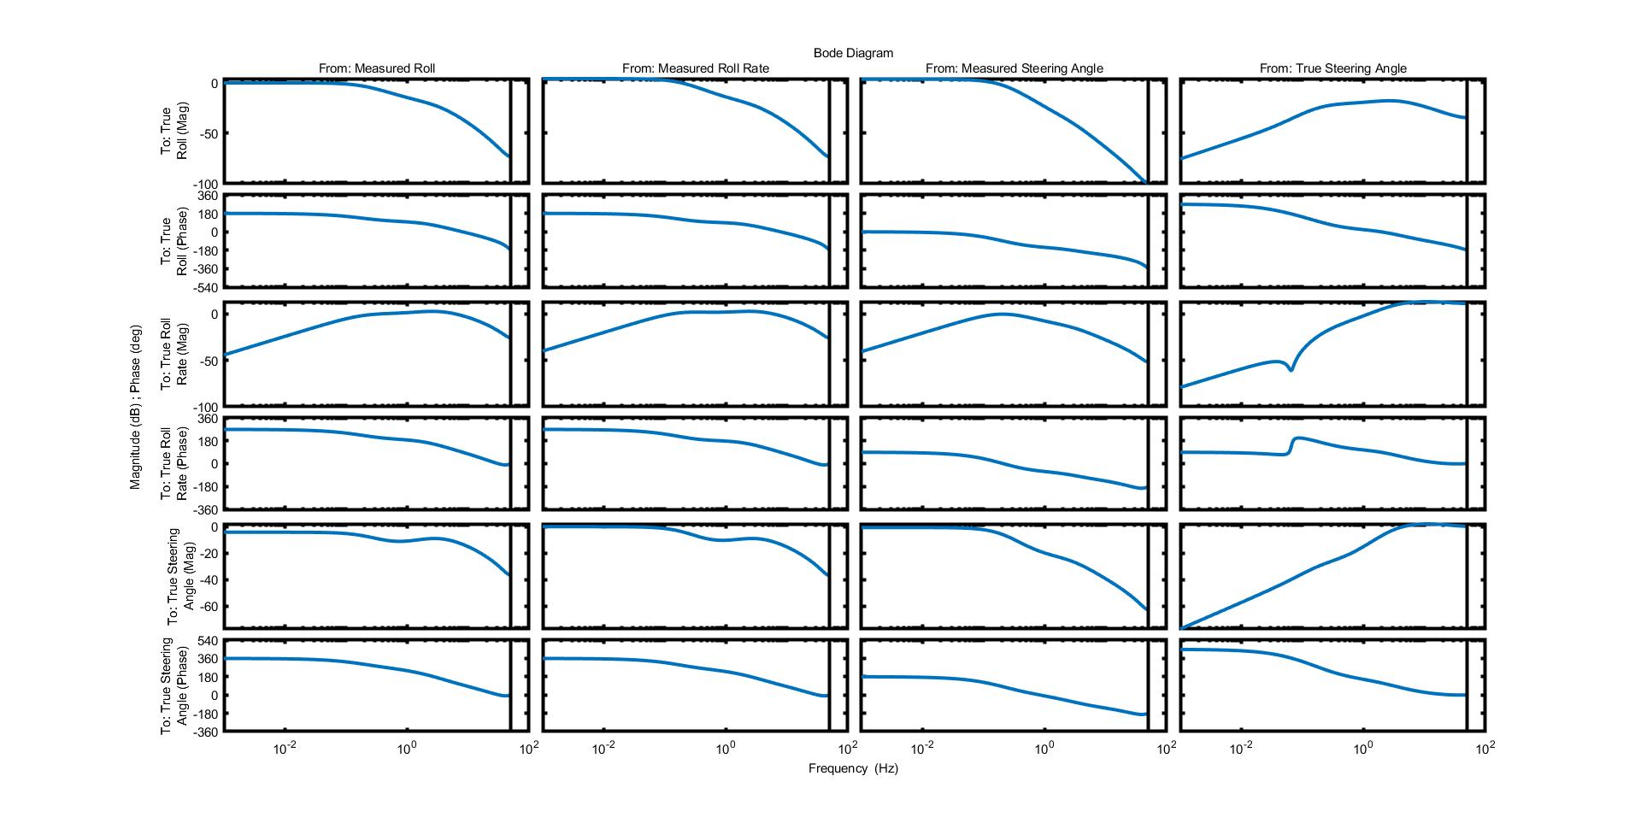

Figure 10 - Bode plots of perturbations. From left to right, disturbances on: true roll, true roll rate, measured steering angle, true steering angle. From top to bottom: Bode magnitude plots measured for true roll, Bode phase plots for true roll, Bode magnitude plots for true steering angle, Bode phase plots for true steering angle, Bode magnitude plots for true roll rate, Bode phase plots for true roll rate.